##### Logical Levels

From Robert Dilts built on the work of Gregory Bateson.

“Where”

“When”

My environment

External context “who I am”.

“What”.

What I do

Specific behaviour

“how”.

My skills and capabilities, strategies

“why”.

“who I am”.

Beliefs and values

Identity

**Values Checklist.**

1. “What is important to you about your career?”

List all replies on a sheet of blank paper. Ideally, no more than eight criteria should be identified.

1. “Which of these is most important?”

*Write 1 against the identified criterion.*

1. “If you have …(criterion no. 1), what is the next most important?”

Write 2 against the identified criterion.

1. “If you have… (criterion no.1) and …. (criterion no. 2), what is the next most important?”

Write 3 against the identified criterion.

1. Continue in this way until all the criteria have been prioritised.
2. “If you have…(criterion no. 1 and (criterion no. 2 and … (criterion no. 3), which is the most important out of … (criterion no. 4) and …(criterion no. 5)?

If 5 is more important than 4, renumber them accordingly.

7. “So if you couldn’t have…(current criterion no. 4) but you could have…(current criterion no.

5), would that be alright?”

If the answer in “No”, the sequence is correct.

If the answer is “Yes”, the sequence is incorrect and 4 and 5 need to be renumbered.

8. Repeat steps 6 and 7 to check the sequence of 5 and 6, 6 and 7, 7 and 8.

This assumes 8 criteria have been listed.

1. Write the list of criteria, in their correct sequence, on to the Values answer sheet. For

each one in turn, ask:

“How do you know when you have… (state the criterion)?”

Write the answer down next to the criterion, using the exact words used.

“What does that mean to you?”

Write the answer down beneath the previous one, again recording the words actually used.

10. When these questions have been applied to all the criteria listed, give the completed

answer sheet to the person whose values they are, for them to highlight significant words

and use them to create a phrase(s) that encapsulates everything that is important to them

about their career.

|  |  |
| --- | --- |
| Exercise 1   * Where do you work?   What are the external influences in your life, and on you?   * What do you do?   Identify your behaviour/characteristics.  Compare with someone else how your behaviours reflect you.   * What skills enable you to do your job?   What are your key capabilities? What are your less useful/developed capabilities?  What are you doing to profile/develop key/less/developed areas?   * What is important to you about what you do?   What factors influence your decisions?   * What do you believe is true about you and those around you that enables you to do what you do?   What beliefs to you hold about yourself?  What beliefs do you hold about your job?   * Who are you?   What is your purpose in business/life?  How would you best describe yourself?   * Of which systems are you a part?   Who are you in relation to the system?  Are you reactive or proactive? | **(Environment)**  **(Behaviour)**  **(Capabilities)**  **(Values)**  **(Beliefs)**  **(Identity)**  **(Mission)** |

|  |
| --- |
|  |

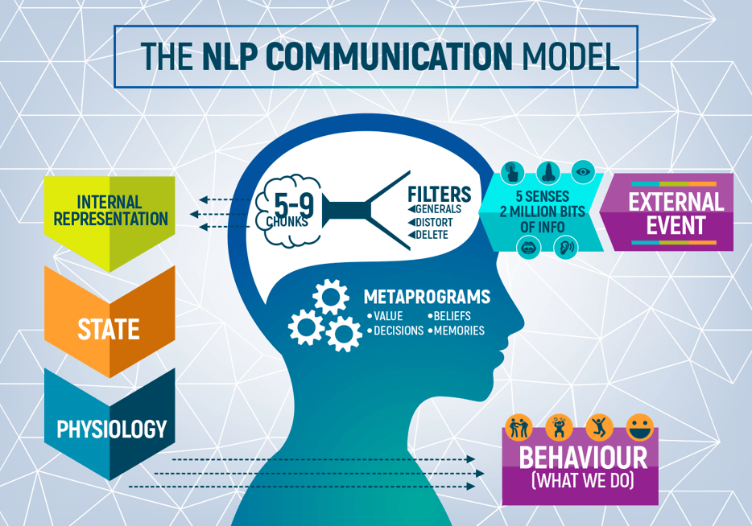

How We Communicate

Our perception of the world is moulded and influenced totally by who we are as individuals, no two people will see the same event in the same way and perceive the same meaning, thinking and feeling as a result of that event.

Anything that happens in our outside world is passed through our filters, which are unique to us.

After passing through our filters the result is that the external event is personalised to who we are, and we give ourselves an "internal representation of our outside world." There is no such thing as a single reality; we make our own realities inside our heads.

Our reality and our internal representations affect our state and our physiology.

Anything that affects our state has an impact on our behaviour.

Our state drives our communication to ourselves and others and how we are thinking and feeling leaks out in aspects of our communication

Physiotherapy Services Development Programme 2012 Copyright© 2012 Griffiths & Associates Ltd

How We Can See Things Differently

Perceptual Positions – Different Points of View

In many everyday situations, the ability to look at a subject from a number of different perspectives can greatly add to the amount of information we have on that subject, and can help us in making better choices and decisions.

In fact, it is useful not only to see things from different perspectives, but also to hear and fell things from different perspectives. In addition, by becoming someone else for a moment, and viewing the situation from their position, we can also take on their filters on the world, their beliefs, values, representations and motivation patterns, and the other ways in which they typically sort and organise their world. Coming out to look at the situation from a detached perspective for a moment will give you an outsider’s opinion. In each position you will collect different, often new, information.

Below are three perceptual positions which you may find useful:

FIRST POSITION

Considering things from your own point of view; see the world through your own eyes, hear it through your own ears, and get in touch with your own feelings.

For some people this can be a very difficult state to maintain it, for example, they are involved in a situation where they feel great sympathy for the other person. Conversely, it can be very hard to “let go” when we are under extreme emotional stress or physical pain.

SECOND POSITION

Considering the situation from the point of view of the other person; that is taking on their position, seeing, hearing, and feeling the world form that position. Taking on their filters, beliefs, values and motivation patterns.

This will profoundly increase out ability to understand the other’s point of view or situation and should not be confused with having to agree with it.

The most effective way to begin to develop stronger second position skills is to physically mirror your communication partner’s posture, gestures, breathing and language.

THIRD POSITION

Considering the situation form the point of view of an uninvolved observer who is outside the situation. In other words, while in the third position you are able to see yourself and everyone else at the same time, and hear what’s going on.

One way of checking that you are in a “true” third position is to notice whether you are still experiencing the emotions of yourself or the person(s). If you are, then you have not yet achieved the third position for that situation