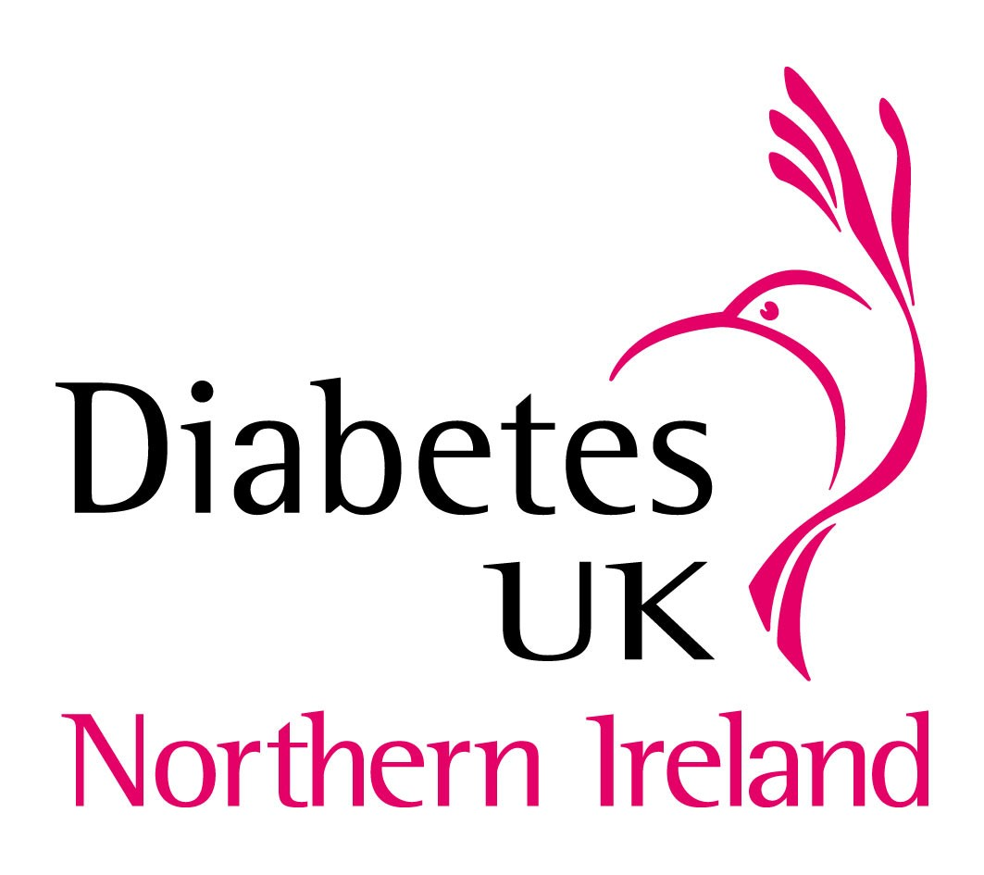
Bridgewood House, Newforge Business Park
Newforge Lane, Belfast BT9 5NW
Tel: 028 9066 6646 Fax: 028 9066 6333
Email: n.ireland@diabetes.org.uk
Web: www.diabetes.org.uk

MEDIA RELEASE

Embargoed until 00.01 Monday 13th June 2011

Children with diabetes need supportive schools

Diabetes UK Northern Ireland is today calling for schools to become more inclusive and supportive of children with Type 1 diabetes.

Launching their Children’s Campaign the charity highlighted difficulties faced by children with diabetes in school. This includes the provision of lunchtime insulin injections to those of primary school age and discrimination in relation to school trips and extra-curricular activities.

Elaine from the Western Board area had personal experience of how difficult it can be to manage. She commented “Ryan had to go on to a lunchtime injection in P3 and unfortunately the school felt they couldn’t support this. At this stage Ryan had already been started on the new regime and I had to postpone going back to work in order to provide the lunchtime injection. Unfortunately, during the winter months this became even more difficult as the bad weather meant I couldn’t travel to the school. Although Ryan’s sibling could walk up the lane and get the bus, I had absolutely no choice but to keep Ryan off as I couldn’t risk him not getting his injection.”

“I now have to go back to work in September and we’re sending Ryan to the Diabetes UK camp this summer to learn how to inject himself. I would appeal to those in the Education Sector to work together and find a solution.”

Joint guidance from the Department of Education and DHSSPS entitled “Supporting Pupils with Medication Needs” published in 2008 stipulates that schools must be sympathetic to medical needs but the administration of medication is a voluntary role for teachers. That said, the Disability Discrimination Act indicates clearly that children should not be excluded from activities and efforts must be made to ensure they are not discriminated against.

Diabetes UK Northern Ireland is urging the Education system to take diabetes seriously and to encourage head teachers to find a solution to the benefit of all parties. Iain Foster, National Director for Diabetes UK Northern Ireland, commented: “While we accept that teachers have a voluntary role in administering medication there is an onus on schools to fully appreciate the duty of care they have in relation to a child and their access to education. A child whose diabetes is not effectively managed is at a disadvantage as their cognitive ability is adversely affected by too high or too low blood glucose levels. The most recent guidance indicates that schools must be sympathetic to medical needs but our evidence tells us this isn’t happening. Rather than turn a blind eye we are urging head teachers and Education and Library Boards to recognise there are problems and to work now to address these. Every child has a right to an education and the right to feel safe when they go to school.”

In terms of lunchtime insulin injections we would like to see, in situations where it is required, a system similar to that in Lincolnshire where existing Classroom Assistants receive a nominal fee to provide insulin injections at school. We would also like to see an immediate stop to unlawful discrimination which prevents children from taking part in all aspects of school life”

A launch event will take place at Stormont as part of the charity’s activities to mark Diabetes Week and encourage debate and discussion about diabetes. Hosted by Conall McDevitt, MLA, the event will bring

together health and education officials and children and parents affected by the issues. Also in attendance will be several newly elected and returned MLAs including Mervyn Storey, Chair of the Assembly Education Committee.

Conall McDevittt, MLA commented: “As a parent of a child with Type 1 diabetes I am deeply concerned about the obvious gap in current guidelines and how they are leaving many young children excluded from aspects of school life.”

“We need new guidelines which respect a child with Type 1 diabetes’ right to education. The current guidelines are out of date and out of line with modern treatment regimes. No parents should have to rely on the goodwill of teachers and individual schools to ensure their child enjoys a full education.”

Why is this important?

Research has indicated that acute hypo and hyperglycaemic episodes during daily routine can be associated with reduced cognitive-motor performance in school-aged children with diabetes. It has been suggested that the initial effect of blood glucose extremes is a decrease in mental efficiency and speed.

This would mean if a child is experiencing a hypo or hyperglycaemia they would find it more difficult to concentrate and also to complete tasks and are therefore disadvantaged in accessing their education.

- ENDS -
For further media information please contact Claire Scullion, Media and Campaigns Manager on 028 9066 6646, mobile 077 6414 5734 or email claire.scullion@diabetes.org.uk

Notes to editor
- The Diabetes UK Careline (0845 120 2960) offers information and support on any aspect of managing diabetes. The line is a lo-call number and opens Monday to Friday between 9am and 5pm (operates a translation service). Recorded information on a number of diabetes-related topics is also available on this number 24 hours a day.
- Diabetes UK is the charity for people with diabetes. We will fund £6 million of medical research in 2011, provide information and support to people with diabetes and campaign on their behalf. For more information visit www.diabetes.org.uk.
- The most recent figures for Northern Ireland indicate that 68,980 people over the age of 17 are living with Type 1 and Type 2 diabetes in Northern Ireland. (Figures from Quality and Outcomes Framework, QOF). It is estimated that thousands more people have the condition but do not know it.
- Latest figures from the NI Childhood Diabetes Register show 963 children aged 17 and under living with Type 1 diabetes. No figures are available for Type 2 diabetes.
- Supporting our work to fund vital research into the care, treatment and hopefully a cure for diabetes as a Diabetes UK Supporting Member entitles you to a range of benefits including our bi-monthly magazine Balance, reliable information booklets on diabetes, our confidential Diabetes UK Careline, over 400 local Diabetes UK support groups, and access to an exclusive personalised Supporting Members Area on our website. If you wish to become a member of Diabetes UK, or for more information on membership visit www.diabetes.org.uk/supportingmember or call supporter services on 0845 123 2399.

